## Activity 1

**Aim:** Create an HTML document using markup Tags in HTML editor (Notepad)

# **Learning outcome**: Able to create simple web pages using HTML 5.

###### **Duration**: 1 hour

# List of Hardware/Software requirements:

* Windows Operating system
* Notepad

## Activity1 A:

## Step 1: Open notepad and create a file with Activity1 A.html extinction. Write this markup language.

##### Input:

##### <!DOCTYPE html>

##### <html>

##### <head>

##### <title>Markup Tags</title>

##### </head>

##### <body>

##### <p>My first Paragraph</P>

##### </body>

##### </html>

## Step 2: Open Activity 1.html file on Brower.

##### Output/Results snippet:

* A simple HTML webpage with the body.

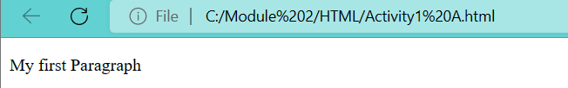

## Activity1 B:

## Step 1: Open notepad and create a file with Activity1 B.html extinction. Write this markup language.

##### Input:

##### <!DOCTYPE html>

##### <html>

##### <head>

##### <title>markup Tags</title>

##### </head>

##### <body>

##### <center>

##### <font size="25">My first Paragraph<font>

##### </center>

##### </body>

##### </html>

## Step 2: Open Activity 1.html file on Brower.

##### Output/Results snippet:

Example -

* A simple HTML webpage with the body.

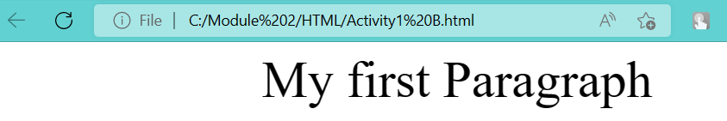

## Activity 2

Aim: Create HTML document using markup Tags in HTML editor (Notepad) (Open/run the html file in web browser to check the output).

# **Learning outcome**: Able to create simple web pages using HTML 5.

###### **Duration**: 1 hour

# List of Hardware/Software requirements:

* Windows
* Notepad

## Activity2 A:

## Step 1: Open notepad and create a file with Activity2 A.html extinction. Write this markup language.

##### Input:

<!DOCTYPE html>

<html>

<head>

<title>Heading and Paragraph</title>

</head>

<body bgcolor="lightblue">

<center>

<font size="18"> Heading and Paragraph</font>

</center>

<h1>My First Heading</h1>

<h2>My First Heading</h2>

<h3>My First Heading</h3>

<h4>My First Heading</h4>

<h5>My First Heading</h5>

<h6>My First Heading</h6>

<p>The Hypertext Markup Language or HTML is the standard markup language for documents designed to be displayed in a web browser. It can be assisted by technologies such as Cascading Style Sheets (CSS) and scripting languages such as JavaScript. Web browsers receive HTML documents from a web</p>

</body>

</html>

## Step 2: Open Activity2 A.html file on Brower.

##### Output/Results snippet:

Example -

* A simple HTML webpage with the body.

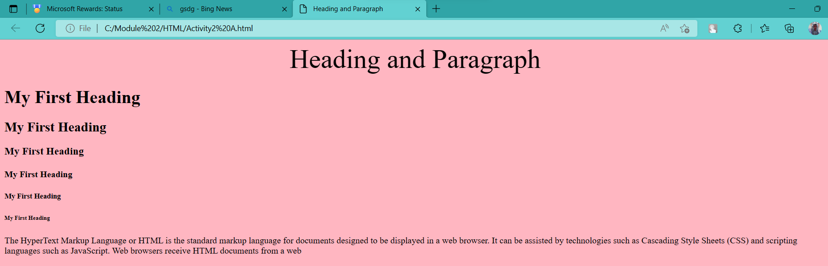

## Activity2 B:

## Step 1: Open notepad and create a file with Activity2 B.html extinction. Write this markup language.

##### Input:

<!DOCTYPE html>

<html>

<head>

<title>Heading and Paragraph</title>

</head>

<body bgcolor="lightpink">

<center>

<font size="18"> Heading and Paragraph</font>

</center>

<h1>My First Heading</h1>

<h2>My First Heading</h2>

<h3>My First Heading</h3>

<h4>My First Heading</h4>

<h5>My First Heading</h5>

<h6>My First Heading</h6>

<p>The HyperText Markup Language or HTML is the standard markup language for documents designed to be displayed in a web browser. It can be assisted by technologies such as Cascading Style Sheets (CSS) and scripting languages such as JavaScript. Web browsers receive HTML documents from a web

</p>

<center>

<font size=20>Line Break</font>

</center>

<p>

HTML, siglos en inglés de HyperText Markup Language (‘lenguaje de marcado de hipertexto’), hace referencia al lenguaje de marcado para la elaboración de páginas web.

<br>Es un standard que sirve de reference del software que conecta con la elaboración de páginas web en sus differences versions, define una estructura básica y un código (denominado código HTML) para la definición de contend de ulna página web, como texto, imágenes, videos, juegos, entre otros. Es un estándar a cargo del World Wide Web Consortium (W3C) o Consorcio WWW, organización dedicada a la estandarización de casi toads las technologies ligands a la web, sobre todo en lo referente a su escritura e interpretación.

</p>

</body>

</html>

## Step 2: Open Activity2 B.html file on Brower.

##### Output/Results snippet:

Example -

* A simple HTML webpage with the body. ( <br> used to brake the line)

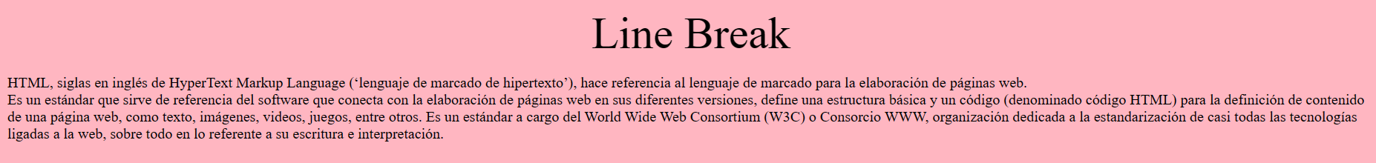

## Activity2 C:

## Step 1: Open notepad and create a file with Activity2 C.html extinction. Write this markup language.

##### Input:

<!DOCTYPE html>

<html>

<head>

<title>Heading and Paragraph</title>

</head>

<body bgcolor="lightpink">

<center>

<font size="18"> Heading and Paragraph</font>

</center>

<h1>My First Heading</h1>

<h2>My First Heading</h2>

<h3>My First Heading</h3>

<h4>My First Heading</h4>

<h5>My First Heading</h5>

<h6>My First Heading</h6>

<p>The HyperText Markup Language or HTML is the standard markup language for documents designed to be displayed in a web browser. It can be assisted by technologies such as Cascading Style Sheets (CSS) and scripting languages such as JavaScript. Web browsers receive HTML documents from a web

</p>

<center>

<font size=20>Line Break</font>

</center>

<p>

HTML, siglas en inglés de HyperText Markup Language (‘lenguaje de marcado de hipertexto’), hace referencia al lenguaje de marcado para la elaboración de páginas web.

<br>Es un estándar que sirve de referencia del software.

</p>

<center><font size=25><font color=white>IBM</font></font></center>

<hr>

<p>The International <b>Business Machines Corporation (IBM)</b> is an American multinational technology corporation headquartered in Armonk, New York, with operations in over 171 countries. The company began in 1911, founded in Endicott, New York, by trust businessman Charles Ranlett Flint, as the Computing-Tabulating-Recording Company (CTR) and was renamed "International Business Machines" in 1924. IBM is incorporated in New York.[7]</p>

</body>

</html>

## Step 2: Open Activity2 C.html file on Brower.

##### Output/Results snippet:

* A simple HTML webpage with the body.( <hr> use for horizontal line)

